# Lab 5: crash reporting

In this exercise, you will:

* Set up simple-breakpad-server as a server for collecting crash reports.
* Configure main.js for sending crash reports.
* Forcibly crashing the app and visualising the entire process of crash submission.

1. Check out the Lab-Crash-Reporting branch from the remote repository.

git checkout origin/Lab-Crash-Reporting

Note: The HEAD of this branch provides the completed code for the entire exercise.

1. Run npm install to ensure all the dependencies have been installed.
2. Create a new local branch for your work based on the "starting point..." commit.

git log --oneline

git checkout <hash for starting point commit>

git checkout -b Lab-Crash-Reporting-mine

1. Start the app.

npm run start

## Start simple-breakpad-server

1. Go to your terminal window from any folder and run below command

npm install -g simple-breakpad-server

Note: This will install simple-breakpad-server globally on your machine.

1. Next step is to start the simple-breakpad-server from any folder outside your project directory. Run below command.

Simple-breakpad-server

Note: This command will start crash reporting server on port 1127. You can visit this url on your browser to make sure it is working fine. <http://localhost:1127/crashreports>

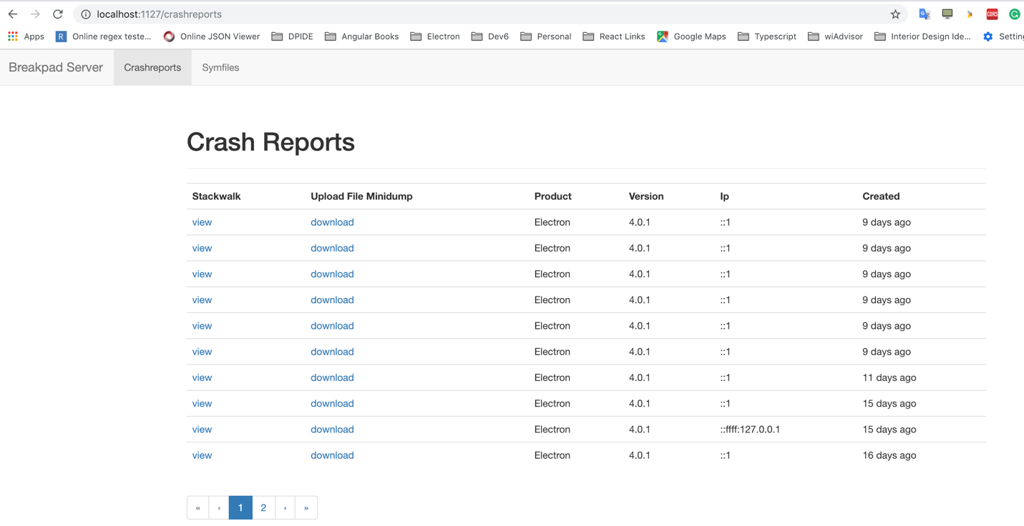

## Configure main.js for sending crash reports.

1. Open main.js (which is at the root level). Paste below lines of code at the top line.

const { crashReporter } = require('electron');

crashReporter.start({

productName: 'electron-shirtastic',

companyName: 'Dev6',

submitURL: 'http://localhost:1127/crashreports',

uploadToServer: true

})

1. Restart the app.

npm run start

## Test crash reporting feature.

1. Navigate to main.js at the root level of project. Add below lines of code anywhere in main.js. Below code is used to forcibly crash the electron application from main process.

process.crash()

1. Restart the app.

npm run start

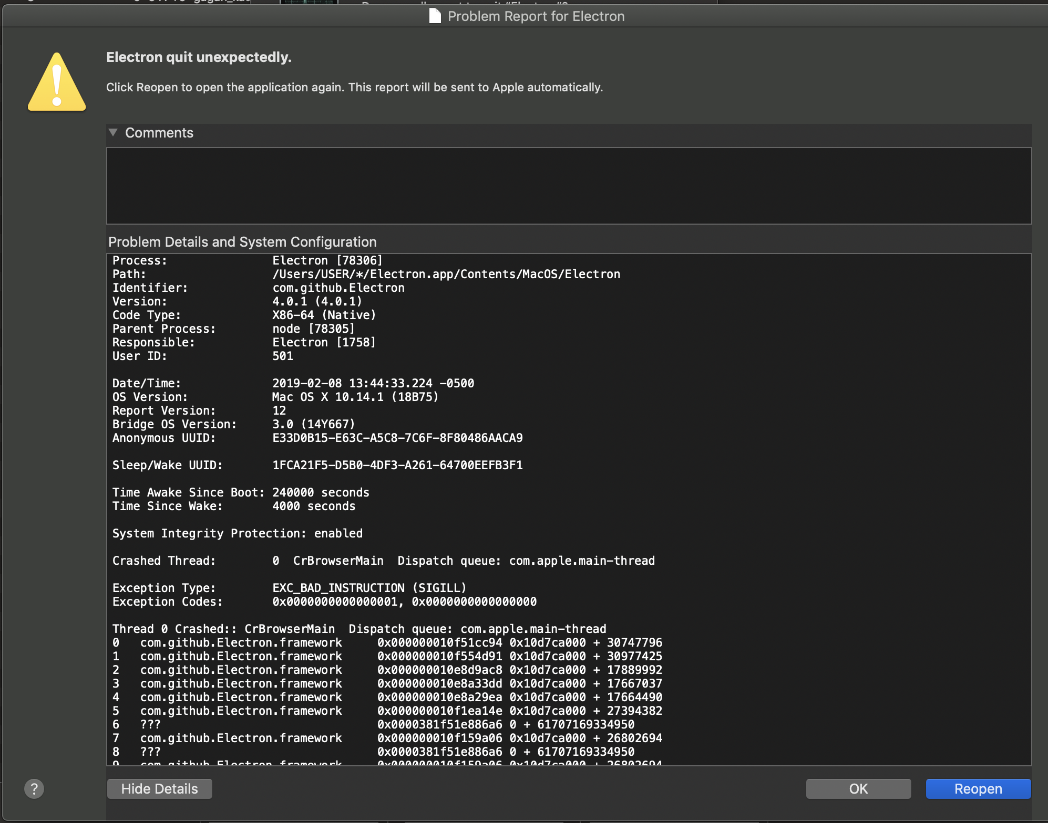

Note: Notice the application will crash as soon you start it and a new crash report will be submitted to server. Go back to localhost:1127 and check a new entry will be present. To read more about crash-reporting and simple-breakpad-server visit below URL’s <https://github.com/acrisci/simple-breakpad-server> and https://electronjs.org/docs/api/crash-reporter